CHAPTER 13
Oligopoly: Firms in Less Competitive Markets
- Chapter Summary
- Learning Objectives
- Chapter Outline
Teaching Tips/Topics for Discussion
Supplemental Content: The Kinked Demand Curve
- Solved Problems
5. Solutions to Review Questions and Problems and Applications

1. Chapter Summary
Oligopolies are industries with only a few firms. A measure of the extent of competition in an industry is the four-firm concentration ratio which states the fraction of each industry’s sales accounted for by the four largest firms.
Barriers to entry make it difficult for new firms to enter an oligopoly industry. Three barriers to entry are economies of scale, ownership of a key input and government-imposed barriers. To analyze oligopolies economists use game theory, which is the study of how people make decisions in situations where attaining their goals depends on their interactions with others. In oligopolies interactions among firms are crucial in determining profitability because all firms are large relative to the market.
The Organization of Petroleum Exporting Countries (OPEC) is an 11 member cartel that colludes to restrict output and increase prices and profits. Michael Porter developed a model showing how five competitive forces determine the overall level of competition in an industry.

2. Learning Objectives
Students should be able to:
- Show how barriers to entry explain the existence of oligopolies.
- Use game theory to analyze the actions of oligopolistic firms.
- Use sequential games to analyze business strategies.
- Use the five competitive forces model to analyze competition in an industry.

3. Chapter Outline
Competing with Wal-Mart
1. Wal-Mart started as small business and grew to be one of a few large companies in the retail sales industry. Ford, Microsoft and Dell also started out small and developed into one of a small number of firms that dominate their industries. These industries are oligopolies.
►Teaching tips: Wal-Mart’s growth has been due to innovative business practices as well as aggressive, and sometimes controversial, policies. At the end of this chapter, “An Inside Look” describes business strategies undertaken by some of Wal-Mart’s competitors. You can assign both of these as reading assignments. The “Thinking Critically” questions at the end of the “An Inside Look” and # 10 of the Problems and Applications can be assigned as homework and used for evaluation.
Oligopoly and Barriers to Entry
1. Concentration ratios are used to measure the fraction of sales accounted for by largest firms in an industry.
- Most economists believe that a four-firm concentration ratio of 40 percent or more indicates an industry is an oligopoly.
- Concentration ratios have flaws.
  - The ratios do not include sales in the United States by foreign firms.
  - Concentration ratios are calculated for the national market even though competition in some markets is local.
  - Competition sometimes exists between firms in different industries.
2. An important reason why oligopolies exist is the presence of barriers to entry in these industries.
- A barrier to entry is anything that keeps new firms from entering an industry in which firms are earning economic profits.
- Barriers to entry include:
- Economies of scale exist when a firm’s long-run average costs fall as it increases output. This is the most important entry barrier.
- Ownership of a key input.
- Government-imposed barriers. Firms may lobby government to impose barriers. A patent is an entry barrier. A patent is the exclusive right to a product for a period of 20 years from the date the product was invented.
►Teaching tips: Table 13-1 lists some concentration ratios taken from the 1997 and 2002 Economic Censuses. It may not be worth the cost of class time to review other concentration ratios from these sources, which are available online from the U.S. Census Bureau, but it is worth mentioning that the ratios change over time in response to changes in industry supply and demand. Industries with high ratios at in one year may have lower ratios in a subsequent year and vice versa.
Using Game Theory to Analyze Oligopoly
1. Game theory is the study of how people make decisions in situations where attaining their goals depends on their interactions with others; in economics, it is the study of the decisions of firms in industries where the profits of each firm depend on its interactions with other firms.
- Games share three characteristics:
- Rules that determine what actions are allowable.
- Strategies that players employ to attain their objectives in the game.
- Payoffs that are the results of the interaction among the players’ strategies.
- In business situations, the rules of the game include not just the laws that a firm must obey, but also matters beyond a firm’s control. A business strategy represents actions taken by a firm to achieve a goal, such as maximizing profits.
- A payoff matrix is a table that shows the payoffs that each firm earns from every combination of strategies by the firms.
- Collusion is an agreement among firms to charge the same price, or to otherwise not compete.
- A dominant strategy is a strategy that is the best for a firm, no matter what strategies other firms use.
- A Nash equilibrium is a situation where each firm chooses the best strategy, given the strategies chosen by other firms.
- A Cooperative equilibrium is an equilibrium in a game in which players cooperate to increase their mutual payoff.
- A noncooperative equilibrium is an equilibrium in a game in which players do not cooperate but pursue their own self-interest.
- A prisoners’ dilemma is a game where pursuing dominant strategies results in noncooperation that leaves everyone worse off.
2. A cartel is a group of firms that colludes by agreeing to restrict output to increase prices and profits.
- In the United States cartels are illegal.
- The Organization of Petroleum Exporting Countries (OPEC) is an 11 member cartel.
- OPEC members meet periodically to agree on the quantities of oil each will produce.
- OPEC’s production quotas are intended to reduce oil production below the competitive level and to increase the profits of member countries.
- OPEC has had difficulty sustaining member quotas and oil prices over time. When prices are high each member has an incentive to stop cooperating and increase output beyond its quota.
►Teaching tips: This section includes numerous examples to help students understand game theory and how it can be applied to explain the behavior of oligopoly firms in different circumstances. A simple duopoly game is illustrated in Figure 13-2; “Don’t Let This Happen to You!” warns students to understand the logic behind this game. “Solved Problem 13-1” analyzes a prisoners’ dilemma using advertising decisions by Pepsi and Coca-Cola. There are three “Making the Connection” features and another game between Wal-Mart and Target is illustrated in Figure 13-3. Problems and Applications related to these features include numbers 5, 8, 9, 10 and 18. You may not want to spend a lot of classroom time on game theory but reviewing one or more examples in class or assigning some of these features as homework will give students an understanding of the interdependent behavior of oligopoly firms.
Sequential Games
1. In many business situations one firm will make a decision and other firms will respond. These situations can be analyzed by using sequential games. Sequential games can be used to analyze strategies designed to deter entry by new firms and bargaining between firms.
►Teaching tips: To understand how a sequential game works students can read “Solved Problem 13-2.” “Problems and Applications” # 18 is related to this problem.
The Five Competitive Forces Model
1. Michael Porter of the Harvard Business School developed a model to analyze the competitiveness of an industry using five competitive forces. The forces are:
- Competition from existing firms.
- The threat from new entrants.
- Competition from substitute goods or services.
- Bargaining power of buyers.
- Bargaining power of suppliers.
►Teaching tips: Porter’s model is the subject of “Problems and Applications numbers” 12 and 19. Spending classroom time on Porter’s model may have a high opportunity cost, but Solved Problem 13-4 (below) applies the model to the music industry, a subject with which many students will be familiar. This can be the basis of either classroom discussion or a homework assignment.

Supplemental Content: The Kinked Demand Curve

Another approach to analyzing oligopoly is known as the kinked demand curve model. To understand this approach, first suppose that Toyota is considering offering a $3,000 rebate on its Highlander sports utility vehicle (SUV). This should cause its sales of Highlanders to increase, but its total costs will also increase as it produces more SUVs. We know from Chapters 11 and 12 that Toyota’s profits will rise if the marginal revenue earned from selling the additional Highlanders is greater than the marginal cost of producing them. To calculate marginal revenue and marginal cost, Toyota must accurately forecast the effect of the rebate on sales. But this may not be easy to do, because the effect of the rebate on Toyota’s sales will depend on whether Toyota’s competitors also begin to offer rebates.
Figure 1 illustrates the problem facing Toyota. If Toyota offers the $3,000 rebate and the other car companies ignore it, Toyota will have succeeded in lowering the price of the Highlander relative to the prices of competing SUVs. This situation is represented by demand curve D₁. The price of Highlanders falls from $31,000 to $28,000, and sales rise from 60,000 per year to 72,000. But suppose that the other car companies do not want to lose sales to Toyota, so they all decide to also offer $3,000 rebates. In that case, Toyota will not have lowered the price of the Highlander relative to other SUVs, because they will all now be $3,000 cheaper. This situation is represented by demand curve D₄. Toyota’s sales will now rise only from 60,000 to 61,000. Of course, Toyota may find that some, but not all, other companies match its rebate. Demand curve D₂ shows what happens if a few firms match the rebate and demand curve D₃ shows what happens when most firms match the rebate. Notice that the more firms that match the rebate, the more price inelastic Toyota’s demand curve becomes.
Figure 1: What Does the Demand Curve for an Oligopolist Look Like?
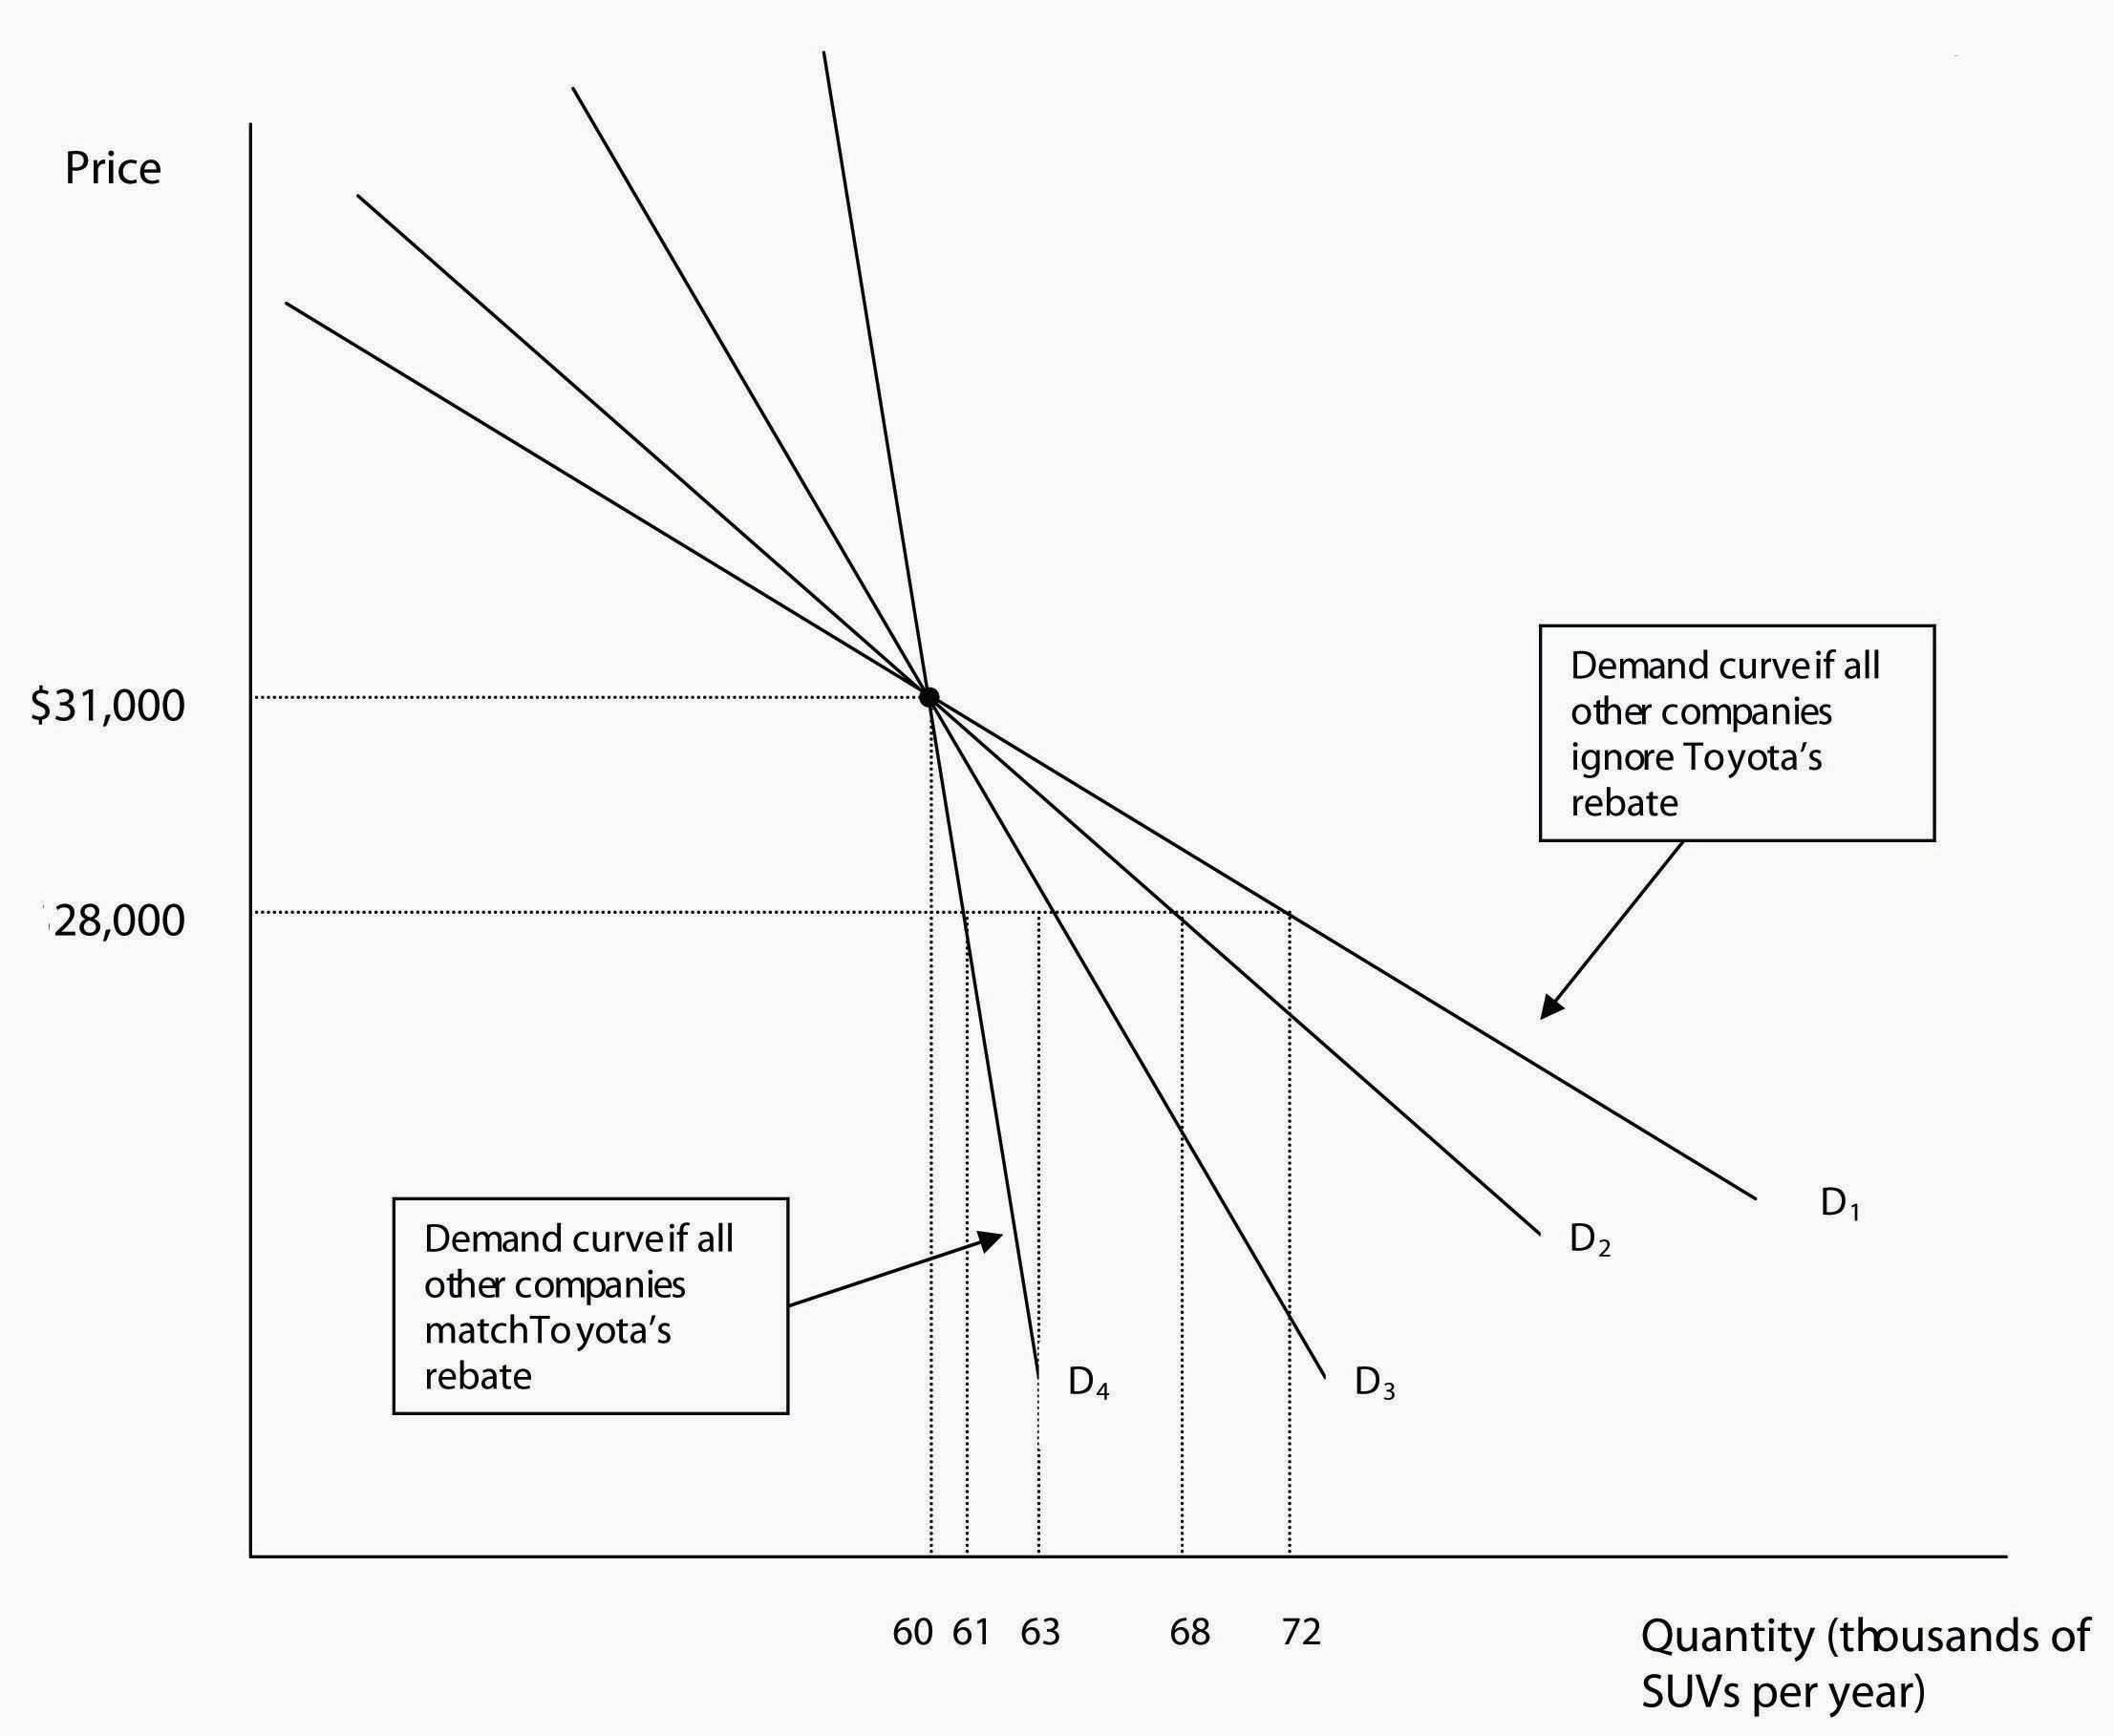

Figure Caption: How many Highlander SUVs Toyota sells after a price cut depends on how the other car companies react. If no other companies match the price cut, Toyota faces demand curve D₁, and cutting the price of Highlanders from $31,000 to $28,000 will increase sales from 60,000 SUVs per year to 72,000. At the other extreme, if all its competitors match the price cut, then Toyota faces demand curve D₄, and its sales will increase only from 60,000 to 61,000. Demand curves D₂ and D₃ show intermediate cases where some, but not all, of Toyota’s competitors match the price cut.

Clearly, how effective the rebate is in increasing sales depends upon how many of Toyota’s competitors decide to match it. Toyota is facing the basic problem of oligopoly: it can only estimate its demand curve by accurately predicting its competitors’ reactions to a price change. How can the managers of a company accurately predict their competitors’ reactions? Economists, marketing managers, and business strategists have struggled with this problem for many years.

One approach is the kinked demand curve model, which uses a demand curve and cost curves to determine the profit-maximizing level of output and price. As we will see, the kinked demand curve model suffers from the drawback that it can accurately predict the behavior of oligopolistic firms only in certain situations. To begin our analysis of the kinked demand curve model, suppose, as we showed in Figure 1, that Toyota is currently selling 60,000 Highlanders per year at a price of $31,000 each. How should Toyota take into account the reactions of its competitors if it changes the price of Highlanders? One possibility is that a company in an oligopolistic industry will expect other firms to react differently to a price cut than to a price increase. For instance, Toyota might expect all of its competitors to match a rebate, because they don’t want to lose sales to Toyota, but to ignore a price increase, because they hope to gain some of Toyota’s customers.
If these expectations are correct, Toyota will face the strange looking demand curve shown in Figure 2. If Toyota’s competitors ignore any change it makes in the price of Highlanders, then it faces the more elastic demand curve, D₁. Price increases will cause many potential buyers of Highlanders to buy a competing SUV, and price cuts will attract many customers who might have bought a competing SUV. But if Toyota’s competitors match any price change, then the effect of the price change on Highlander sales is fairly small. In this case, Toyota faces the less elastic demand curve, D₂. But if Toyota’s competitors ignore price increases and match price cuts, the company will face the kinked demand curve shown by the solid line in Figure 2, made up of the segment of D₁ above the current price of $31,000 and the segment of D₂ below $31,000.
Figure 2: A Kinked Demand Curve
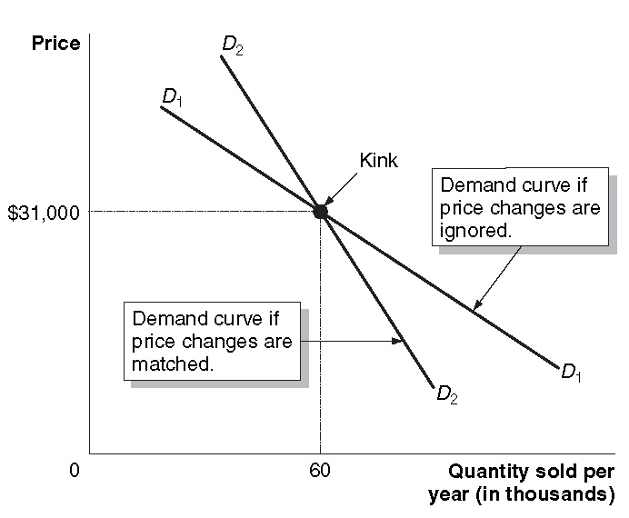
Figure Caption: If an oligopolist’s competitors ignore its price changes, it faces demand curve D₁. If an oligopolist’s competitors match its price changes it faces demand curve D₂. If its competitors match its price cuts and ignore its price increases, then it will face a kinked demand curve (shown by the solid line in the figure) made up of demand curve D₁ for prices above the current price and demand curve D₂ for prices below the current price.

What difference will having a kinked demand curve make to Toyota’s decision about how many Highlanders to produce and what price to charge? Figure 3 helps provide the answer by adding marginal revenue and marginal cost curves.
Figure 3: A Kinked Demand Curve Leads to Stable Prices

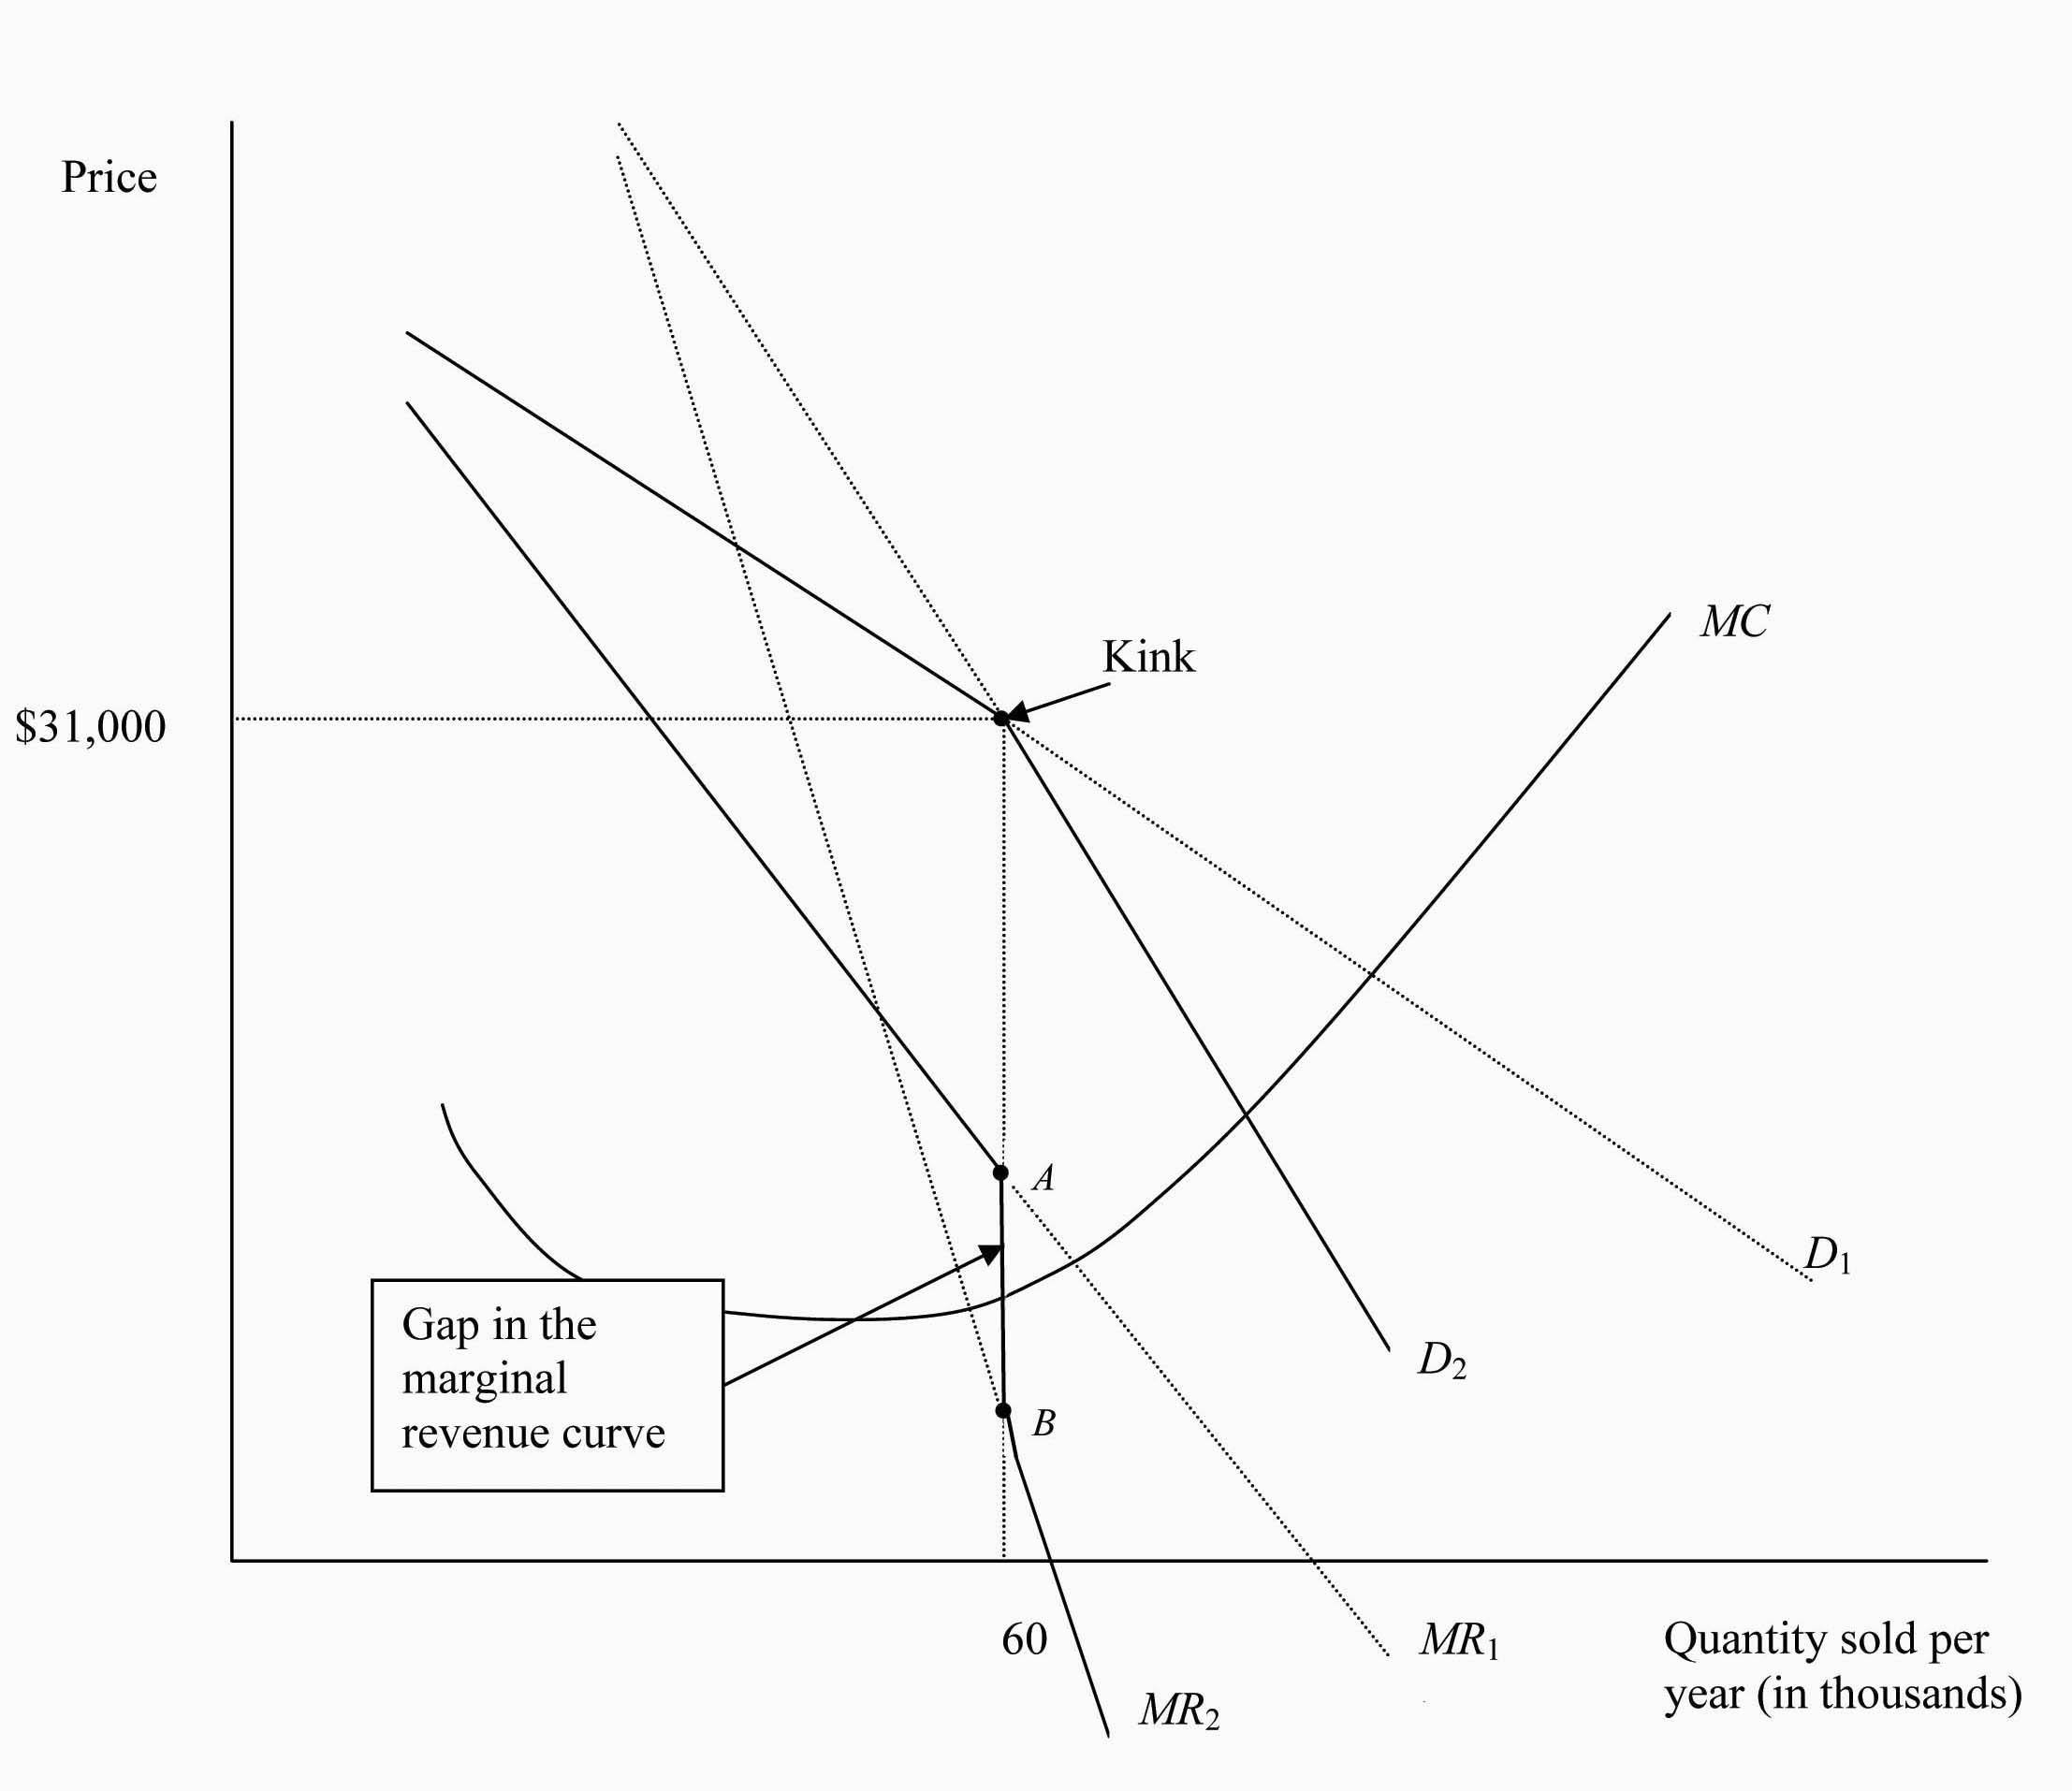

A

B
Figure Caption: Because of the kink in the oligopo list’s demand curve, the marginal revenue curve will have a gap in it, shown by the vertical line between points A and B. As long as marginal cost stays within this gap and demand doesn’t change, the firm will continue to produce the same amount and charge the same price.

Because the demand curve for Highlanders is composed of segments of two demand curves, the marginal revenue curve will be composed of the corresponding segments of two marginal revenue curves. As Toyota moves down demand curve D₁, MR₁ will be the marginal revenue curve. When it reaches the kink – at output of 60,000 – and starts to move down demand curve D₂, MR₂ becomes the marginal revenue curve. But notice that there is a gap between the two segments, shown in the figure by the vertical line between points A and B. At point A, marginal revenue drops from MR₁ down the vertical line to point B on MR₂. So, the marginal revenue curve for Highlanders consists of a segment of MR₁, the gap or vertical line between A and B, and a segment of MR₂. (To prove to yourself that there must be a gap in the marginal revenue curve, try drawing this figure. Keep in mind that for a linear, or straight-line demand curve, the marginal revenue curve will be twice as steep as the demand curve.)
Remember from Chapters 11 and 12 that to maximize profits a firm will produce the level of output where marginal revenue equals marginal cost. Figure 3 shows that to maximize profits, Toyota should produce 60,000 Highlanders and charge a price of $31,000. The gap in the marginal revenue curve leads to the following interesting result: Increases and decreases in marginal cost may not lead to changes in the output and price combination that maximizes profits. As long as the marginal cost curve intersects the marginal revenue curve somewhere between A and B, a quantity of 60,000 and a price of $31,000 still maximizes profits.
The kinked demand curve model helps to explain why firms in oligopolistic industries keep their prices constant in circumstances where firms in more competitive industries would raise or lower them. But the model falls short of being a complete story of oligopoly for two reasons:
- In our example, it does not explain how Toyota initially decided to produce 60,000 Highlanders and charge a price of $31,000. The analysis focuses instead on explaining why, once the firm has already decided on a combination of output and price, it may not change output and price very frequently.
- The assumption that all competitors match price cuts and all competitors ignore price increases is hard to justify. It happens some of the time in some industries, but it cannot be used as a general rule.
In recent years, economists have turned away from trying to fully explain the behavior of oligopolies using graphs like Figures 3. Instead they have used the game theory approach described in Chapter 13.

4. Solved Problems
Chapter 13 includes two Solved Problems to support learning objectives 2 (Use game theory to analyze the actions of oligopolistic firms) and 3 (Use sequential games to analyze business strategies). The following Solved Problems support this chapter’s two other learning objectives.

Solved Problem 13-3 Supports learning objective 1: Show how barriers to entry explain the existence of oligopolies.

Minimum Efficient Scale in the Automobile Industry
The U.S. automobile industry often has been cited as an example of oligopoly. The industry is an oligopoly because of the existence of economies of scale. In order to achieve minimum efficient scale of operation (MES) automobile assembly plants for light vehicles (passenger cars and light trucks, including minivans and sport utility vehicles) must produce about 200,000 units per year. The size of the domestic market for light vehicles in the U.S., including imports, has been around 16.5 million units since the late 1990s. Since 2001 the domestic production of light vehicles has been around 12 million units. To produce this number of vehicles at the lowest possible cost there can be no more than 60 assembly plants (12,000,000/200,000 = 60), but the number of assembly plants can be fewer than 60 since each plant can produce more than 200,000 units at minimum unit cost.. Since automobile companies own and operate multiple assembly plants there are only three U.S. firms: DaimlerChrysler, Ford and General Motors (The Big Three).

Toyota, Honda, Volkswagen and other foreign-owned companies increased their share of the U.S. market for light vehicles beginning in the 1970s as higher energy prices caused many consumers to demand the smaller, more fuel-efficient models these companies specialized in producing. Subsequently, several foreign companies established manufacturing operations in the U.S. to better serve the market and avoid restrictions on automobile imports. By 2004 13 foreign-owned assembly plants had been established; six of these plants are located south of Indiana and Ohio. These two states and Michigan are home to 44 percent of all light vehicle manufacturing plants. Further erosion of the Big Three automakers’ share of the light vehicle market would have serious consequences for employment in these mid-western states.

Source: Thomas Klier, “Caution Ahead – Challenges to the Midwest’s role in the auto industry,”
Chicago Fed Letter, The Federal Reserve Bank of Chicago, February 2005.

- Would economies of scale in the automobile industry allow for more than three U.S. firms?
- How would additional loss of market share by Big Three U.S. automakers affect employment in Michigan, Indiana and Ohio?

Solving the Problem:
Step 1: Review the chapter material. Since the problem is about barriers to entry you may want to review the section “Oligopoly and Barriers to Entry” which begins on page 414 in the textbook.
Step 2: Answer question (a). Many other firms contribute to the production of parts and services for automobiles but the assembly of light vehicles is the part of the production process in which the Big Three specialize. The owner of a new assembly plant would have to produce and sell at least 200,000 light vehicles to compete in this market. It would be very costly for a new firm to do this since it would have to establish a distribution system, marketing campaign, etc., in addition to an assembly plant. Established firms such as Honda and Toyota that already have established markets in the U.S. are much more likely to be successful, but a new assembly plant would still have to produce and sell at least 200,000 vehicles to achieve the minimum efficient scale of operation. There are two sources for these sales: (1) market share may be taken from other automakers (2) the annual market for light vehicles could grow beyond 16.5 million units.
Step 3: Answer question (b). As the import share of the light automobile market in the U.S. increases, this would reduce the demand for automobiles assembled at plants owned by Big Three firms. Since many of these assembly plants are located in Michigan, Indiana, and Ohio, it is likely that job losses would have a disproportionate effect on these states. The establishment of foreign-owned assembly plants in these states would mitigate these losses, but this would not occur if the plants are located outside of these states.

Solved Problem 13-4 Supports learning objective 4: Use the five competitive forces model to analyze competition in an industry.

Analyzing Competition in the Music Industry Using the Five Competitive Forces Model
Until 2004 the music industry was dominated by the Big Five major record companies, which accounted for about 75 percent of a $25 billion market in CDs and related products. A merger in 2004 between Sony Music Entertainment and BMG Entertainment reduced the Big Five to the Big Four: EMI, Sony-BMG, Warner Music Group and Universal Music Group. The following is a competitive analysis of the music industry prior to the late 1990s; that is, before consumers began to download music on a wide scale over the Internet. The competitive analysis follows Michael Porter’s five competitive forces model that is designed to assess the degree of competition in an industry.
- Competition from existing firms. Significant competition existed among the largest firms, but little between the Big Five and smaller firms. Little change occurred over time in the market share of the Big Five firms.
- The threat from new entrants. Barriers to entry made the potential threat from new entrants negligible. The financial resources required to establish a recording artist or group were substantial. Sound and video recordings had to be made and distributed; contracts had to be made with venues where the artists would perform. It was difficult for a new firm to become established.
- Competition from substitute goods or services. Music was essentially available and playable in one format, the CD, and from one source: the music company that owned the rights to an artist’s recordings. Therefore, few substitutes were available.
- Bargaining power of buyers. Buyer’s options were limited. They only could obtain music from one format and the Big Five had considerable control over the prices of CDs.
- Bargaining power of suppliers. Since recording artists were compelled to work with one of the Big Five they had little negotiating power. Terms included in record contracts for new performers were very standardized.

Changes in the degree of competition in the industry have come about since the late 1990s primarily due to new technology. Widespread access to personal computers, MP3 encoding and the Internet have made it possible for consumers to copy and distribute music at low cost.

Source: Google Answers: April 5, 2004. http://answers.google.com/answers/threadview?id=325373

Analyze the competitiveness of the music industry in the early 21st century using Porter’s model.

Solving the Problem:
Step 1: Review the chapter material. You may want to review The Five Competitive Forces Model since this problem refers to the material in this section of the textbook. The section begins on page 430.
Step 2: Competition from existing firms. New music technology has reduced the start-up costs for new artists. High quality recordings can be made, copied and marketed directly through the Internet. Some artists have even established their own companies, bypassing the Big Four. Competition is likely to erode the market share of the Big Four in the future.
Step 3: The threat from new entrants. Entry barriers have been lowered by the new technologies. New artists are less dependent on the traditional marketing network. Music can be advertised and sold directly from the artists’ web sites. The threat from entrants has increased.
Step 4: Competition from substitute goods or services. More substitutes are available for consumers. If the format used by record companies is not what consumers want or if music is sold at high prices, consumers can easily download it through the Internet. Consumers who want only two or three songs from a CD with 10 or more songs can download only those they want.
Step 5: Bargaining power of buyers. As the availability of substitutes has grown so has the bargaining power of consumers. Since consumers can download songs at little cost beyond their time, the Big Four companies have had to offer consumers lower prices and different formats.
Step 6: Bargaining power of suppliers. As noted in the previous steps, musicians and consumers can use the Internet to bypass the traditional distribution networks and are less dependent on established companies, in particular the Big Four. Therefore, the bargaining power of suppliers has waned.

5. Solutions to Review Questions and Problems and Applications

Answers to Thinking Critically Questions

1. Wal-Mart’s success comes mainly in selling products that it purchases in large quantities directly from manufacturers. If the demand is great enough it may begin offering plus-sized women’s clothing, but it wouldn’t have an advantage in offering home installation and repair services for electronic goods, so it is doubtful that it will begin this activity.

2. Wal-Mart seems to benefit from significant economies of scale. As its size grows, it can negotiate even better deals with suppliers, and reduce its average fixed costs from things like advertising, store design, and goods tracking technology.

Answers to Review Questions

1. Oligopoly is a market structure in which a small number of interdependent firms compete. Examples include cigarettes, beer, aircraft, breakfast cereals, autos, and pet food.

2. Barriers to entry keep new firms from entering an industry, reducing the extent of competition in the industry. The important barriers to entry are economies of scale, ownership of a key input, and government-imposed barriers.

3. Government imposed barriers to entry include patents, occupational licenses, barriers to international trade (like tariffs and quotas), and franchises. One reason governments are willing to erect barriers to entering an industry is that firms do favors for politicians who enact such provisions (for example, contributing to campaigns). Another reason is that these barriers may improve the standard of living in the long run; for example, granting patents encourages the development of new products and technologies.

4. Game theory is the study of how people make decisions in situations where attaining their goals depends on their interactions with others. A cooperative equilibrium is one in which players in a game cooperate to increase their mutual payoff. A noncooperative equilibrium is one in which players don’t cooperative but pursue their own self-interest. A dominant strategy is one that is best for a player, no matter what strategies other players use. A Nash Equilibrium is a situation in which each player chooses the best strategy, in light of the strategies chosen by the other player(s).

5. Because there as so few firms in markets which are oligopolies, each firm must pay attention to the moves (strategies) of the other firms. Game theory is the methodology that examines how to make decisions when attaining one’s goals depends on interactions with others, so it is natural to use game theory when studying oligopoly.

6. A prisoners’ dilemma is a game in which pursuing dominant strategies results in noncooperation that leaves everyone worse off. The outcome of noncooperative pricing (competition) will leave firms worse off than if they cooperated and set higher prices.

7. Explicit collusion involves making an agreement about not competing. In implicit collusion no formal agreement is reached, but firms tacitly avoid competing with each other.

8. Even when the prisoners’ dilemma is the outcome of a one-shot game, the outcome of a repeated game can be cooperation, especially if there is some enforcement mechanism that punishes a player who doesn’t cooperate.

9. In a sequential game one player (firm) acts first, and then other players respond. A decision tree allows players to map out how the other player(s) will respond to their actions, finding the action that yields the highest payoff.

10. Porter’s five competitive forces are 1) competition from existing firms, 2) the threat of competition from new entrants, 3) the threat of substitute goods or services, ) the bargaining power of buyers, and 5) the bargaining power of suppliers. The strength of these forces changes over time. For example, a small supplier might grow into a virtual monopolist – as happened to IBM in its dealings with Microsoft.

Answers to End of Chapter Problems and Applications

1. Prices are likely to be higher in the industry in which companies always match price changes, because firms will be reluctant to cut prices and quick to copy others who increase their prices.

2. If a firm doesn’t match a price cut, its sales may fall considerably; if it doesn’t match a price increase, its sales will rise.

3. a. The two vendors are likely to have lower combined profits than a single vendor would. Therefore, the city is likely to receive less in total license fees from two vendors.
b. People will be better off with two vendors, because competition will result in lower ice cream prices.
c. A longer licensing period means that the vendors will play the pricing game with each other for a longer period, which would increase the likelihood that they reach a cooperative outcome and set higher prices. By selling licenses to new vendors each year, the city decreases the likelihood of competition and between the vendors, and increases the likelihood they will charge lower prices.

4. a.

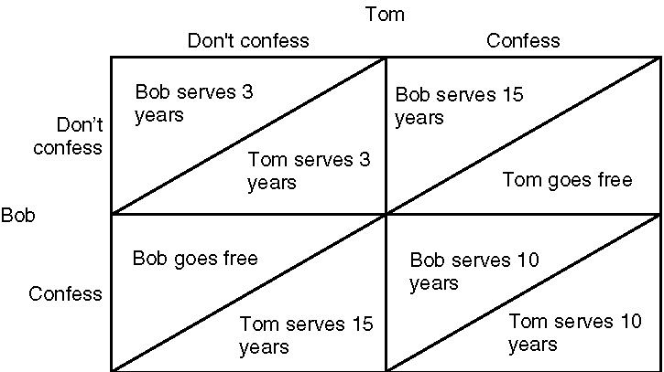

b. Confessing is a dominant strategy for Bob.
c. Confessing is a dominant strategy for Tom.
d. They will both confess, so they will both serve 10-year sentences. In this situation, this outcome is difficult to avoid, but if they had both refused to confess, they would both have served only 3-year sentences.

5. The argument is incorrect. The best strategy for each player is to not cooperate, no matter what the other player does.

6. Early decision plans may have put “big-name” colleges in a prisoners’ dilemma.

7. a. It would appear that they are in a prisoners’ dilemma. If large numbers of players take steroids or other illegal drugs, then the performance of each player does not improve relative to most other players. The players are worse off because of the side effects of the drugs.
b. If the players are in a prisoners’ dilemma, testing would make the players collectively better off – their average pay should be unchanged, but their long-term health will improve because they won’t use steroids any more.

8. If advertising is a prisoners’ dilemma, as in Solved Problem 13-1, then a ban on advertising beer on television is likely to increase the profits of beer companies.

9. a. The Nash equilibrium occurs when both companies bid $4 billion and each earns profits of $0.75 billion.
b. If they expect to be bidding on many similar projects in the future, they are more likely to avoid the prisoners’ dilemma outcome by both bidding $5 billion.

10. a. Wal-Mart doesn’t have a dominant strategy. If Target uses bar codes, Wal-Mart earns more profit when it also uses bar codes, but if Target uses RFID tags, Wal-Mart’s best strategy is to use RFID tags.
b. Target doesn’t have a dominant strategy. If Wal-Mart uses bar codes, Target earns more profit when it uses bar codes, but if Wal-Mart uses RFID tags, Target earns more by using RFID tags.
c. Recall the definition of a Nash equilibrium: A situation where each firm chooses the best strategy, given the strategies chosen by other firms. In this problem there are two Nash equilibria: Both firms choosing bar codes or both firms choosing RFID tags. In either of these situations, neither firm can increase its profits by changing its strategy, given the strategy chosen by the other firm. An important point to note is that it is possible to have a Nash equilibrium even when neither firm has a dominant strategy.

11. Low barriers to entry meant that it was easy for new firms to enter the cotton textile industry. Frequent technological innovation meant that firms’ costs would be falling and firms would have an incentive to cut prices. Frequent firm bankruptcies meant that exit from the industry was also common. Competition is more likely when the cast of players in the industry is changing more rapidly and when some have inherent advantages over others (such as new technology).

12. Economic structure would include whether there are economies of scale in the industry, whether one or more firms owns a key input or raw material, whether there are government imposed barriers to entry or competition, the threat of substitute goods or services, the bargaining power of buyers and the bargaining power of suppliers. Most economists agree that economic structure is the main determinant of the intensity of competition in an industry, but other factors, like the personalities involved, might occasionally play a role.

13. Because there is less competition in the less-than-truckload industry, companies will charge higher prices. Less-than-truckload companies should also earn higher rates of return.
.
14. As the personal computer industry evolved during the 1990s and early 2000s, differences between the machines offered by the computer companies narrowed. So, personal computers became more of a commodity business. In a commodity business, consumers are making their decisions primarily on the basis of price. Therefore, a price ware is a worse strategy in a commodity business because if one company cuts the price of its product, competitors have little choice but to match the price cut.
15. Collusion makes firms better off because if they act as a single entity, like a monopoly, they can reduce output, increase prices and increase profits. Among the reasons that every industry doesn’t become a cartel are that the high profits caused by collusion will induce new firms to enter the industry; because each member of the cartel has an incentive to “cheat” on the collusive agreement, earning the highest profit by producing more than its share when everyone else sticks with the collusive agreement; and because collusion is illegal in the United States.

16. Entrepreneurs hope to increase profitability by creating “big businesses.” Unless there are significant economies of scale, they will not be successful, however. In the figure, firms producing Q₁ have the lowest average costs. If a firm tries to grow to a larger size, say Q₂, it average costs will rise – from C₁ to C₂ in this case.

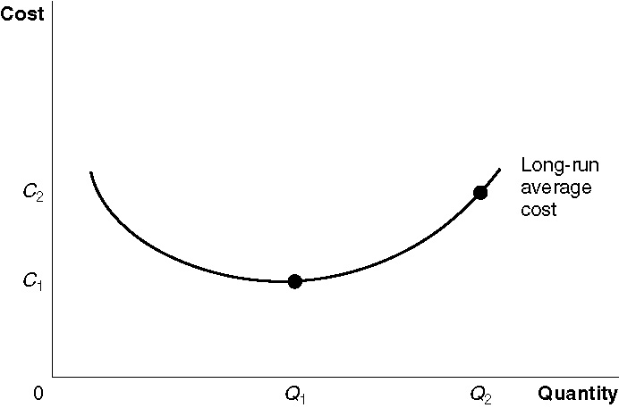

17. By posting prices before they went into effect, an airline could see what the reaction of its competitors to the price change would be. If firms matched a price cut or failed to match a price increase, the airline could cancel the price change before it had actually taken effect.

18. Your answer does depend on the minimum rate of return owners of fast-food restaurants require on their investment. For instance, suppose the minimum required return is 15 percent. Then Burger King will enter whether McDonald’s builds a large store or a small store. So, McDonald’s should build a small store, because it will receive a return of 20 percent, rather than 16 percent. But suppose the minimum required return is 20 percent. Then Burger King will not enter if McDonald’s builds a large store. So, McDonald’s should build the large store, in which case it will earn a return of 25 percent.

19. Firms in these industries will not earn an economic profit. To earn an economic profit, they need to offer a product or service that competitors have difficulty copying.

20. Having more flights, flying more different models of planes, and having areas for different classes of passengers on each plane raises costs. Southwest Airlines avoids these costs by pursuing the strategy outlined in Making the Connection 13-4.

21. The practice of decimation will change the payoff matrix, increasing the payoff from staying relative to the payoff from running away for individual soldiers. If the increase in the relative payoff from staying is high enough, the practice will induce some soldiers to stay who might otherwise have run away. There is a positive feedback effect. As fewer run away, the incentive for any single individual to run away goes down, as well. However, if the odds of getting killed in battle are too high, decimation won’t change the decision to run away. A ten percent chance of death after the battle won’t dissuade many soldiers from running away if they face nearly certain death on the battlefield. The policy of decimation also had the drawback that if any soldiers in a unit ran away, then every soldier in the unit was subject to the same penalty whether he had run away or not.

22. “Being the competition” means copying the business model of another firm. “Being the competition” sometimes makes sense. On example would be when there is no other option available in the industry – such as in a perfectly competitive industry. Another case in which “being the competition” makes sense is when their business model fits your firm better than their own.

23. Both cutting the price while holding features constant and holding prices constant while adding new features will decrease profits. In deciding which of these strategies to use, the business will probably assess consumer demand to see which of these two consumers prefer.

24. As Chandler suggests, there are many firms in these industries because smaller firms can produce at a lower long-run average cost than larger firms.

25. Suppose that there are originally several firms producing a small quantity, as at point A. If one firm expands in an industry with sizeable economies of scale, moving to point B, it can cut its prices well below the average costs of the other firms and drive them out of business.

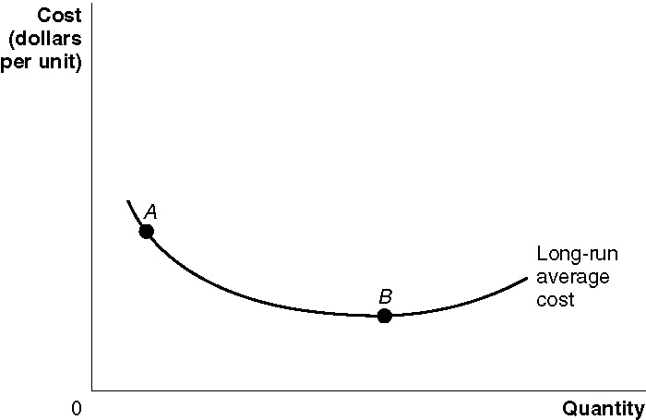

26. a. There would be one or more firms like LittleAuto.
b. A single firm like BigAuto will probably dominate the market.
c. There will probably be two or more firms like BigAuto, depending on the how large demand is.

27. LRAC₁ would most likely be associated with a perfectly competitive industry and LRAC₂ with an oligopoly.

